

**Rich Web Applications: Assignment 1**

**Student Names:** Daniel Molloy, Wiktor Lesiak

**Student Numbers:** B00086546, B00087701

**Course:** Computing in Information Technology BN013

**Year:** 3rd Year

**Title of Assignment:** Rich Web Applications: Assignment 1

**Due Date:** Sunday 3rd of December

**Date Submitted:** Monday 4th of December

The Material contained in this assignment is the authors original work, except where work quoted is duly acknowledged in the text. No aspect of this assignment has been previously submitted for assessment in any other unit or course.

Signed: ____________________ Signed: ____________________

Date: ___/___/______

Table of Contents

Abstract 3

Design of Application 3

Features 4

Screenshots 4

How it Works 6

What We Learned From this Project 6

References 7

# Abstract

The purpose of this assignment was to develop skills and the knowledge on how to create a professional and engaging web application that will enhance the user experience when using the app. This project was performed in a group of two and together we overcame the challenges to create a fully functioning web application. Some of the technologies we used to achieve this goal were HTML, CSS and TypeScript. For this assignment, we had to create a food app that provides details about the type of restaurants that people can dine in throughout Ireland, we also had to include certain details of each restaurant like the title of the restaurant, address, picture of restaurant, opening hours, cuisines and facilities.

# Design of Application

Before we began coding the application we first began drawing up a wireframe for each page of the web application. We found an online tool to help us do this. Once we were happy with how to wireframe looked we moved onto developing the application itself. We started with organising the folders of our project folder to make things much easier for ourselves in the future. After creating our file structure, we began coding the html of our application while including Bootstrap elements to help with the design of the navigation bar. We used the text editor called Brackets[1] to help us develop the site, it gave us real time error checking while also supporting all the languages we used this assignment.

As there was two of us working on this assignment we decided to split the work load between us, by this we both were working on separate features of the website while communicating between each other for any issues we came across while coding of implementing them.

To help us develop our skills with Angular design we used the documentation on the official Angular website[2]. On the website, we found tutorials to help us complete key features of our website.

# Features

Our application includes the following features:

* A visually appealing home page.
* A selector for the counties.
* A list of all restaurants within a selected county.
* Details of each restaurant.
* The option to submit a review.

# Screenshots

**Header**

**Home page**

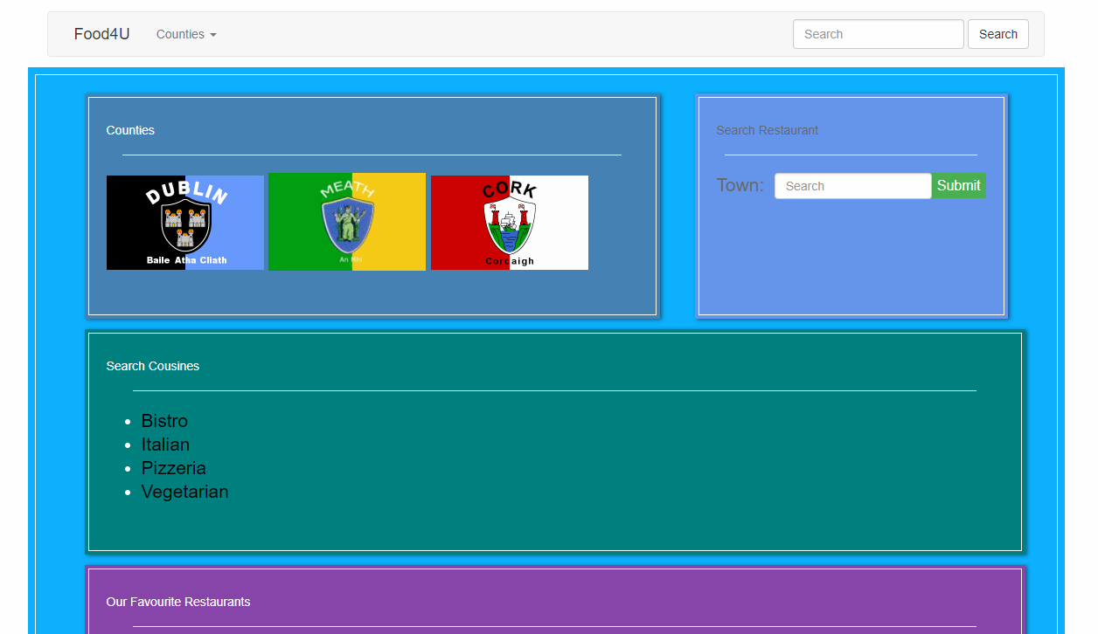

**County page**

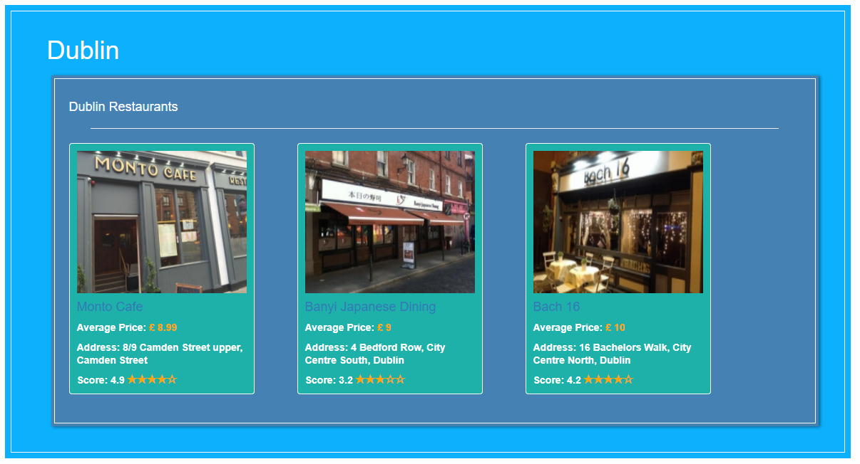

**Restaurant detail page**

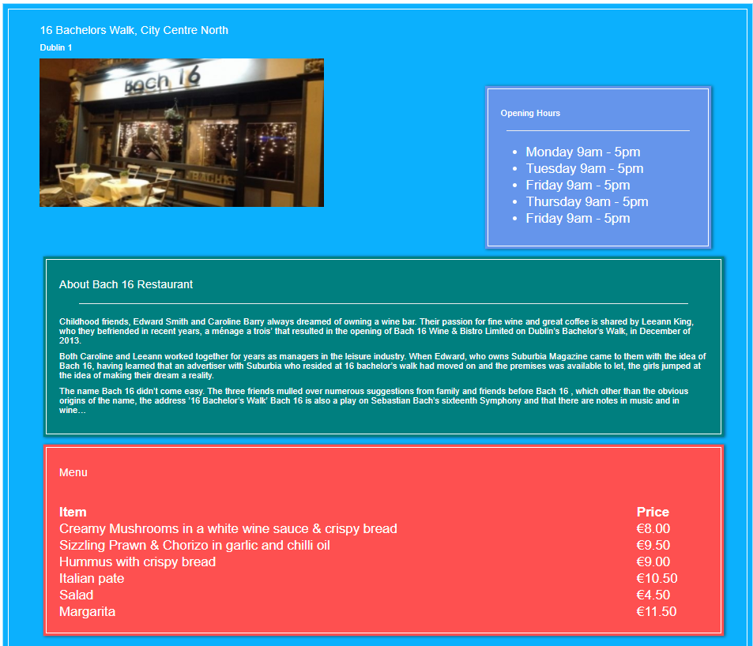

# How it Works

Our website includes a bootstrap navigation bar template which we learned from following a tutorial on tutorialspoint[3]. To link each page of the web application we used the angular component RouterLink[4], this component allowed us to traverse our web application with ease. For each county page, we run the summary-service which has the details needed for each restaurant. This allows us to continuously update the website and add a new restaurant very easily without making any CSS changes to the we application.

# What We Learned From this Project

In this project, we learned how to split work between two people efficiently and communicate between each other to complete a challenging assignment. We both developed our skills with typescript, a language we were only introduced to over the last few months, and the use of angular components. We did run into some time management issues as we ran into a few problematic issues during the development of the web application, but we finished it in the end. If we were to do it again we would manage our time much more efficiently.

# References

1. <http://brackets.io/>
2. <https://angular.io/docs>
3. <http://www.tutorialspoint.com/bootstrap/bootstrap_navbar.htm>
4. <https://angular.io/api/router/RouterLink>